Year 11 ATAR
Modern History
Unit 1
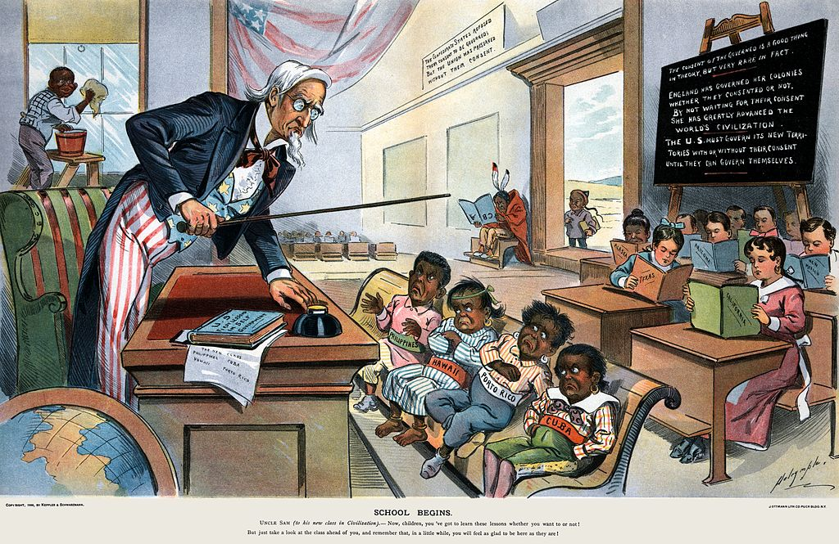

The Age of Imperialism

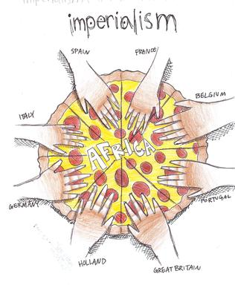

Course Documents

